
Bruce. A Weinberg

Department of Economics
Ohio State University
1945 North High Street
Columbus, OH 43210-1172

Phone: (614) 292-5642
Fax: (614) 292-3906

June 1, 2012

Professor William Masters
E-mail to: Vankeerbergen.1@osu.edu

Dear Mitch:

This letter is to accompany the proposed Geographic Information Science Minor. We discussed this minor at our meeting today. This minor is new for semesters. As discussed in the proposal, much of the course work is built around the themes incorporated in the Geographic Information Science and Technology Body of Knowledge, compiled by the Education Committee of the University Consortium of Geographic Information Science. The subcommittee also noted (and commented favorably on) the relatively high level of the course work. Overall, the minor is well designed and likely to appeal to students. We approved the minor unanimously.

Sincerely,
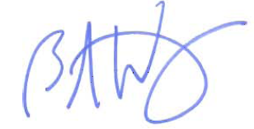
Bruce A. Weinberg
Professor and Director of Undergraduate Studies

